
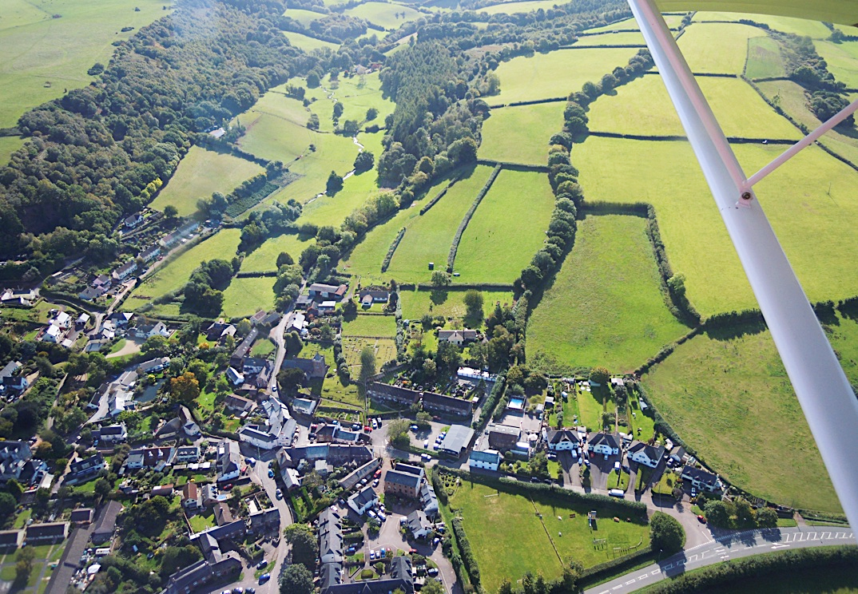

Light refreshments will be provided.

St Petrock’s History Group

Local History Group
for Timberscombe, Wootton Courtenay and Neighbours
Members £1. Visitors £4 each.
St Petrock’s Church, Timberscombe
Monday 19th November
at 7.00pm

Light refreshments will be provided
Rob Wilson-North
Head of Conservation & Access, Exmoor National Park Authority
will give a talk on

The archaeology of Timberscombe hillfort

During the 1990s Timberscombe hillfort came to wider notice and since then has been investigated archaeologically. Rob Wilson-North reviews what we know about this important archaeological site and explains how it fits into Timberscombe’s own story, and that of Exmoor.

