Exmoor Society Guided Walk

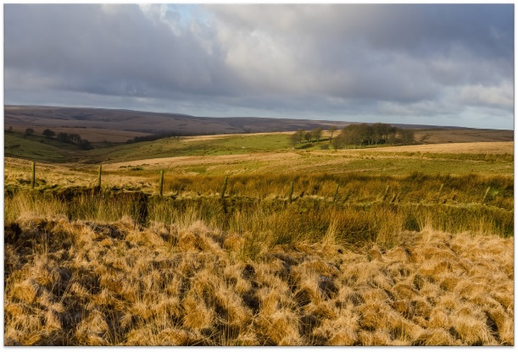

Larkbarrow Farm

Knights, knights and WWII on Exmoor

Saturday 18th May 2019, 10:00am - 1:00pm

Starting near Alderman’s Barrow, in the company of local experts, this walk will visit evidence of knights from the bronze, medieval, Neolithic, and Victorian ages. At Larkbarrow we will hear about the Knights who tried to reclaim Exmoor and we will find evidence of World War Two’s impact on Exmoor. Hopefully there will be red deer to see near Three Coombes Foot.
5 miles / 3 hours approx.
Meet 10am Alderman’s Barrow cattle grid SS 835 422

