WHAT ARCHAEOLOGISTS DO TO BUILDINGS – WITH AN EMPHASIS ON SOMERSET HOUSES
AN ILLUSTRATED LECTURE BY DR STUART BLAYLOCK
ALL ARE WELCOME
Dr Blaylock is an archaeologist and specialises in buildings in the West Country and beyond, with an interest in domestic architecture and churches

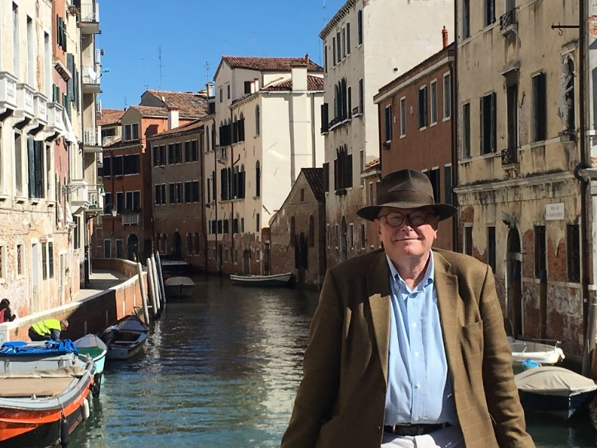

MONDAY 10TH JUNE AT 6PM
ST PETROCK’S CHURCH, TIMBERSCOMBE

PUBLIC LECTURE. NO ENTRANCE CHARGE. LECTURE FUNDED BY THE NATIONAL LOTTERY HERITAGE FUND
ANY VOLUNTARY DONATIONS WILL GO TOWARDS THE FUND TO PROVIDE AN ACCESSIBLE TOILET AND SERVERY IN THE CHURCH, OPEN EVERY DAY TO ALL


