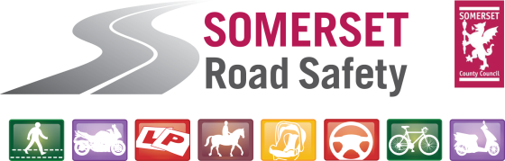
Route 60+
Helping you drive safer for longer

Route 60+ is a FREE presentation for older drivers, addressing how both vehicles and driving skills have changed over the years and how these can be updated.




When and Where

Date: 16th January 2020

Time: 10:00-13:00

Location: Wootton Courtenay,
Village Hall

The Route 60+ presentation offers coping strategies to take into account the increased amount of vehicles on the road and, as we get older, our ability to adapt our driving skills.

For more information contact Somerset Road Safety on 01823 423430 or roadsafety@somerset.gov.uk.

www.somersetroadsafety.gov.uk

A one hour driving refresher with an approved driving instructor is also available at a time and location convenient to you (a charge of £25 will be made for this service, payable on the day).

Those attending can expect to receive:

- A ‘goodie’ bag including a hi-vis jacket and a copy of the latest Highway Code
- Free refreshments

