Wootton Courtenay Parish Council
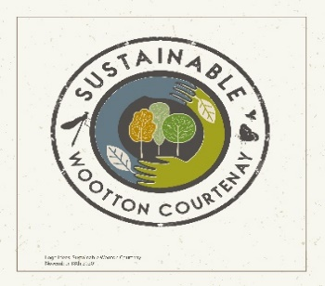
Climate and Ecological Emergency Declaration
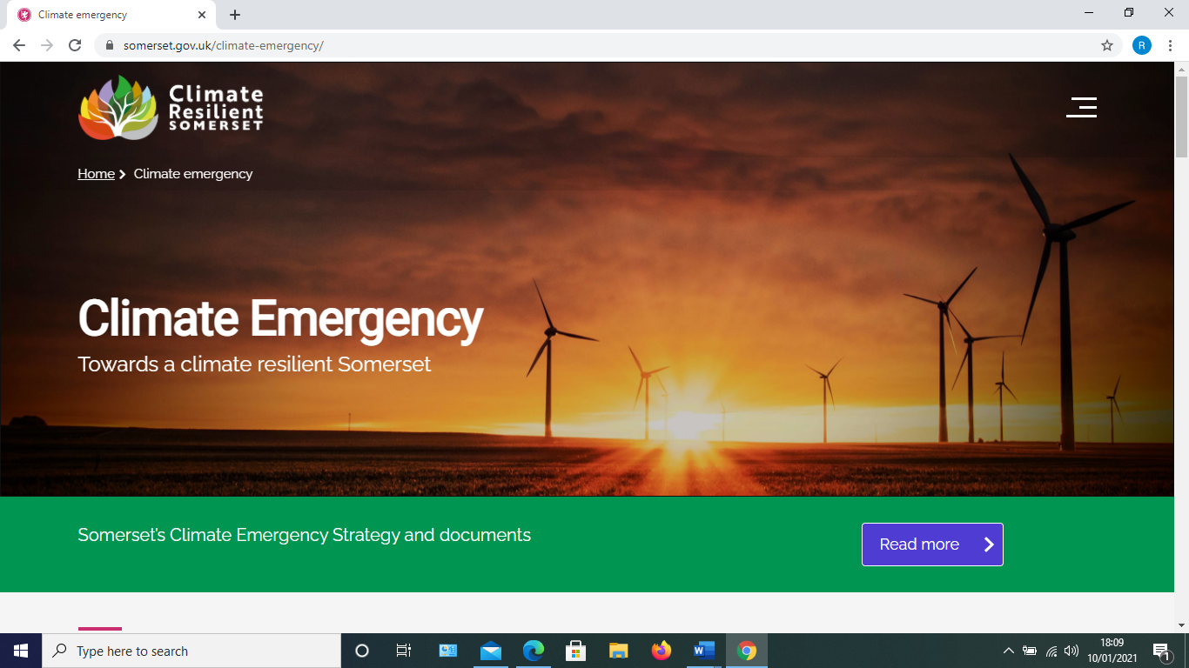

The global scientific consensus is that humans have already caused irreversible climate change, the impacts of which are being felt around the world. It is imperative that we contribute to the limitation of global warming to well below 2˚Celsius* by reducing greenhouse gas emissions resulting from our activities in both production and consumption of products and services.
Wootton Courtenay Parish Council declares a Climate and Ecological Emergency in recognition of the clear evidence that climate change represents a threat to the life opportunities and well-being of future generations and biodiversity, and needs to be addressed at all levels of government. The climate and ecological emergency are intrinsically interlinked.

It further declares that its future actions and decisions will take account of the need to reduce
emissions of greenhouse gases and reach net-zero carbon by 2030.

The Council also recognises that raising awareness and engaging the community in addressing the challenges of climate change will result in many benefits in terms of health, wellbeing, economic and community resilience.

The Parish Council acknowledges its important role in facilitating carbon reduction by supporting, and working in collaboration with, community groups, businesses and individuals to make effective improvements.

In partnership with organisations and the village community the Parish Council pledges to assist with the protection and enhancement of biodiversity and sustainability.

* (Adopted by the UN Paris Agreement 2015)

Agreed at a Parish Council Meeting on …10/3/2021……Reviewed 11/01/2023…………

VILLAGE PROGRESS TO DATE

1) The Village Hall, built in 2000, was made from sustainable materials with local labour. It is exceptionally well insulated
and fitted with a heat replacing ventilation system. Since its construction the hall has been fitted with a 4 Kw solar
panel generation system and refitted with LED internal and external lighting. In 2001, the hall won an award for its
sustainable credentials.

2. The village shop and post office has been fitted with a 2 Kw solar panel generation system and double glazing for the
residential accommodation. Future plans include replacing shop lighting with LED lights.

3) 1400 trees planted.

4) Wootton Courtenay Parish Council, in partnership with Porlock, Luccombe, Selworthy and Minehead Without Parish
Councils, has submitted a bid on behalf of Porlock Vale to the Somerset Climate Emergency Fund to:

a) introduce water refill points; This has not yet been achieved.
b) set up a repair café run by volunteers to reduce the volume of items sent to refill
c) achieve Plastic Free status;
d) support the community agriculture project entitled “Good Vibe Veg”

4) A community group, Sustainable Wootton Courtenay, has been set up to address climate change, ecological and
biodiversity issues.

